NAME: SHIVRAJ CHIRMURE

UID: 2005044

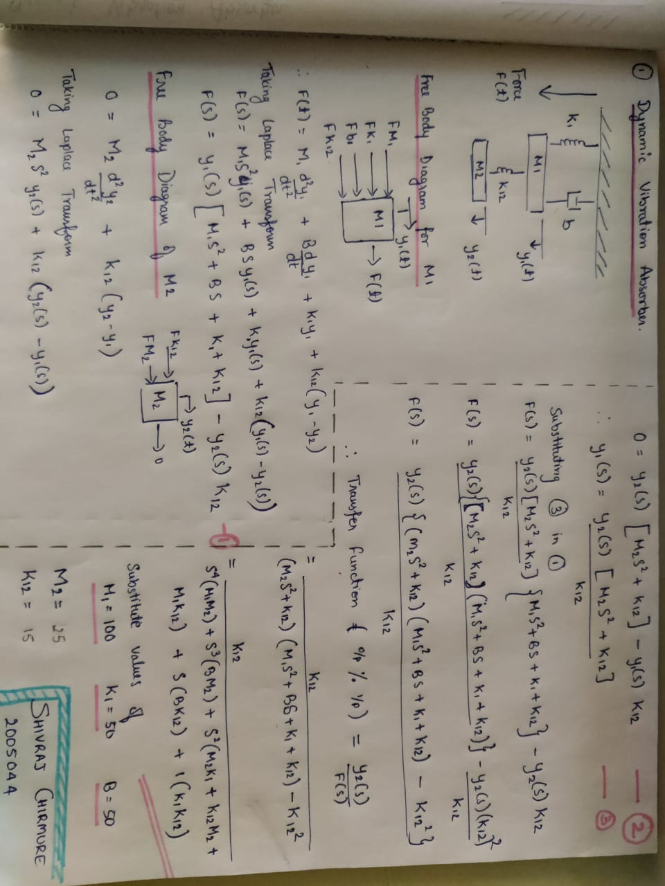

Output:

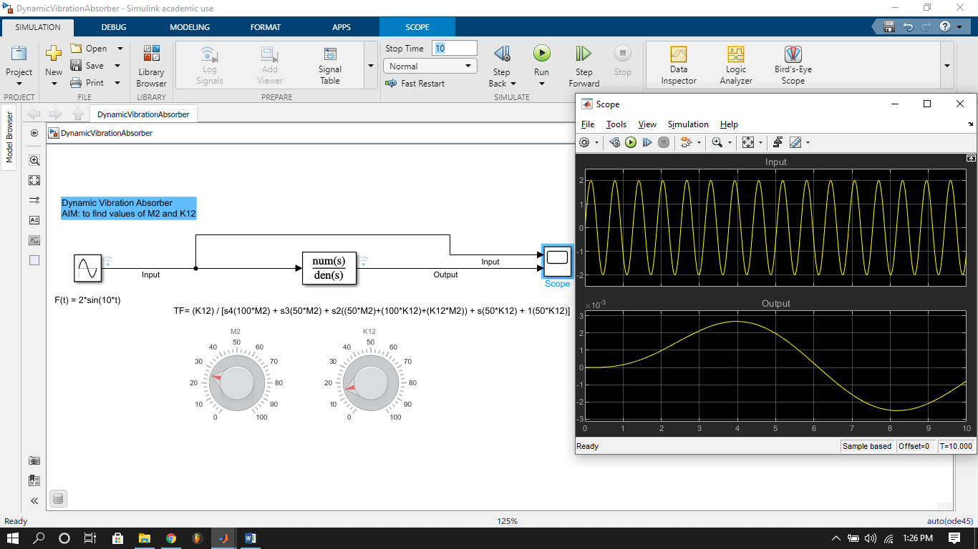

On simulating the model for 50 seconds, after 30 seconds the system was stable with the values as follows:

K12 = 15

M2 = 25

